**SPH3U 9.2 Waves at Media Boundaries**

1. **Media boundaries**

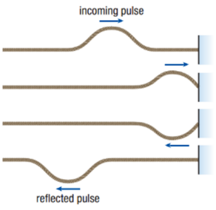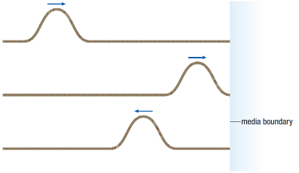

|  |  |
| --- | --- |
| Media boundary: | where a wave goes from one medium into another |
| Free-end reflection: | wave goes from one medium to a less dense medium (air) |
| effect | wave bounces back unchanged |
| Fixed-end reflection: | wave goes from one medium to a more dense medium (wall) |
| effect | wave bounces back inverted |

|  |  |
| --- | --- |
| Transmission of waves: | in the real world, the wave splits. part is transmitted (goes forward into new medium) and part is reflected (like above) |

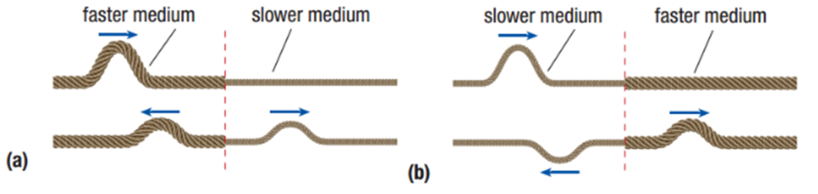

1. **Standing waves**

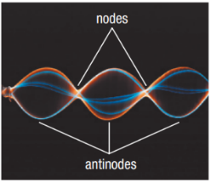

|  |  |
| --- | --- |
| Standing wave: | a wave that looks like it’s “standing still” |
| cause | waves interfere with their own reflections as they bounce up and down the medium |
| nodes | points where particles aren’t moving |
| antinodes | points where particles move the most |

1. **Standing waves – 2 fixed ends**

|  |  |
| --- | --- |
| Fixed end: | the end of the medium is held tight in place, so that it must have a node |
| 2 fixed ends | also called “fixed-fixed” (string instruments) |

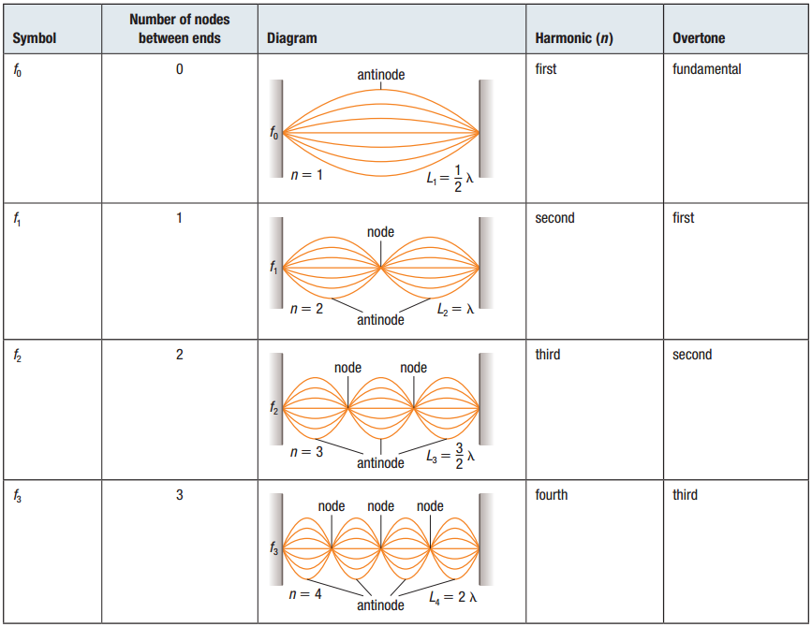

1. **Standing waves – 2 free ends**

|  |  |
| --- | --- |
| Free end: | the end of the medium can move freely – it will have an antinode (maximum) |
| 2 free ends | also called “free-free” (brass instruments) |

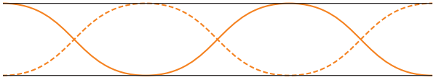

1. **Standing waves – fixed-free ends**

|  |  |
| --- | --- |
| Fixed-free ends: | node on fixed, antinode on free (woodwind) |

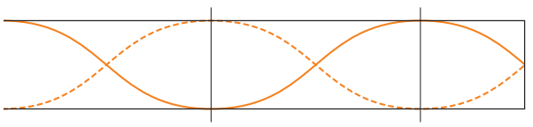

1. **Equations**

|  |  |
| --- | --- |
| 2 fixed or 2 free: |  |
| Fixed-free: |  |

The speed of a wave on a string with a fixed end and a free end is 350 m/s. The frequency of the wave is 200.0 Hz. What length of string is necessary to produce a standing wave with the first harmonic?

The sixth harmonic of a 65 cm guitar string is heard. If the speed of sound in the string is 206 m/s, what is the frequency of the standing wave?

**Homework:** page 426: #5-7